Reading Challenge - Soundtrack
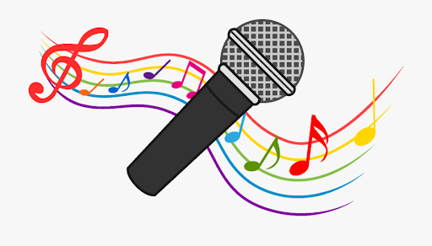
Imagine the book is turned into a film.
Decide on the soundtrack to go along with the film.
Decide what songs you would include and what events and/or characters they would link to from the storyline.

Song Title | Artist | Event or Character this would link to and why.

